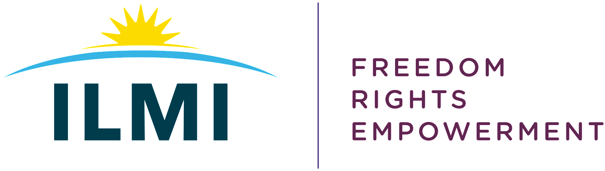
ILMI submission to the Joint Committee on Gender Equality
Thursday 23th June

Fiona Weldon

Good morning everyone and thank you for the opportunity this morning to share our experiences and observations regarding the Citizens’ Assembly recommendations regarding Care and Social Protection in relation to disabled people.

We speak to you today as disabled women and not women with a disability. This is a social-rights and political right stance to our understanding of disability and this will underpin our contributions today.

Both myself and Eileen work for ILMI. ILMI is a national cross impairment Disabled Persons Organisation (DPO) that seeks a better Ireland for all disabled people. We are acutely aware that disabled people live in a world that systematically excludes them from the ordinary rhythms of daily living.

We agree that gender equality is a matter of human rights, social justice and fairness and very much welcome the recommendations that the citizens assembly have made to tackle the issue.

Disabled people as a whole experience inequalities that have a detrimental impact on both our life chances and quality of life, but we feel very strongly that we cannot address gender equality unless we address the reality that disabled women need to be, and feel equal to their non-disabled counterparts! 13.8% of women in Ireland are disabled women - that’s a lot of us!

Disabled women are not homogonous, we are all intersectional. We hold many identities - such as gender, race, ethnicity, social class, religion, sexual orientation, ability and these identities can overlap with one another. Understanding intersectionality with regard to disability is essential for the creation of appropriate laws and policies and the design and delivery of accessible, inclusive services.

Each and every one of us have our own unique experiences of discrimination and we must consider everything and anything that can marginalise us. Article 6 of the UNCRPD states that disabled women experience multiple discrimination.

Ireland, having ratified the UNCRPD, must take measure to ensure disabled women have their human rights and fundamental freedoms adhered to and our government must put in place empowerment measures to ensure their full participation in everyday living including education, employment, and family living.

Disabled women experience the same inequalities as non-disabled women. However, their situations are exacerbated by social and cultural attitudes to disability as well as environmental barriers. Disabled women:

- have a lower uptake of health screening
- are more likely to experience sexual violence
- experience barriers to parenting
- are disproportionately affected by the extra costs that they face as disabled people.

It is our lived and professional experience that disabled people do not want to be reliant on their family for support unless both parties agree. Disabled people do not want carers, home helps or support services that impede their life chances to live like everyone else, these services only allow disabled people to exist and not live.

We want and need access to tailored person centred supports that promote choice, control and self-determination in the form of Personal Assistance (PA) if required. This provision must become a right and not be subject to resource availability.

A PA is an individual contracted by a disabled person to provide them with the support they need in different aspects of daily living. This assistance can look different for all of us (some of us do not need a PA will others need some, and others need a lot). Some of the tasks that a PA can carry out includes support with intimate care, being a home maker, assistance at school, university, in the workplace, parental support or when out and about, some disabled people need assistance with money management, navigating their environment or support with directing their PAS. There is no cut-off age for this provision of support.

It is our belief that parents of disabled children need support to understand the social model of disability and the systematic barriers disabled people face. As a Disabled Persons Organisation or DPO, we recognise that many of the so-called supportive structures mostly promote exclusionary practices that separates disabled people from their non-disabled peers, in the home, at school, at work and when socialising.

We feel that capacity building is paramount to support parents to demand their right to quality support to ensure that their children grow up to live good lives and this includes the provision of inclusive education. Parents should also not be forced into battling with healthcare professionals to get the supports that their children need. Disabled children have rights just like every other child.

Parents must have access to appropriate tailored person-centred supports that assist them with their parental duties if and when required and this must become a right.

They must also be supported to work and have a career if they so wish. They must not be forced into giving up work or reduce their hours or advance their careers just because they are obliged to stay at home. It is also worth mentioning here that there is an additional cost factor for families of disabled children and adults.

Disabled women need access to appropriate healthcare which meets their specific needs. Many healthcare services are inaccessible. Last year ILMI hosted a consultation session with disabled women from across Ireland. The stories we heard about going for a mammogram, or cervical check or seeking gynaecology services were stark. Disabled women want a dignified experience. It is their belief that health care professionals require disability equality training to understand the inequalities that disabled women face.

Disabled women are more at risk of sexual abuse and violence than there non-disabled counterparts. Disabled women need access to accessible information and awareness training about what constitutes sexual abuse and violence.

We want all related health care services and support agencies / groups that work with survivors to be well informed and be well equipped to support us and these services must also be easily accessible. We want disabled women to be empowered to speak up and have a no tolerance view to sexual abuse and violence.

Presently, 63.7% of disabled women are mothers and yet they are barely referenced in our current maternity strategy. Moreover disabled people are often denied the right to make reproductive decisions, including decisions about fertility, contraception, pregnancy, childbirth and parenting. This is a human rights violation. As disabled women we don’t want the powers that be to assess our ability to have children nor question our ability or skills to look after them. As women it is our human right to have children if we so wish.

All disabled people if required must have the right to the supports they need to live their lives and this needs to include having the right to a Personal Assistant Service to support them with family living, including assistance with parental duties. This current service is very ad hoc, and many disabled people are forced into being dependent on family or aforementioned care-type services that barely allow them to exist.

Some disabled people that want to have a family can be forced to undergo a Parenting Capacity Assessment, this is scandalous and it is just another way of oppressing us, which can be exacerbated for women with intellectual impairments.

Disabled women also must have a right to tailored support if they choose to have an abortion, this should be tailored to meet individual needs with accessible information to accompany this support.

Disabled women must have the right to prenatal and postnatal support. This includes having access to all of the services that non-disabled women have. These need to be both accessible and tailored to meet the needs of all disabled women. We believe strongly that staff must undergo disability equality training. Disabled women also must have the right assess IVF treatment if it is their wish, and any supports or systems in relation to IVF need to be disability equality proofed.

Things to be mindful of regarding work and social protection payments for disabled people:

2016 data showing just 30 % of disabled people had third-level education compared to 47 % of non-disabled people. Disabled girls / teenagers must have equal access to a broad range of subject choices which reflects their personal abilities, interests, and passions. The report highlights "inequality for accessing third-level qualifications for young disabled people compared to their non-disabled counterparts and says there is a "lack of career guidance for many disabled students prior to leaving school”.

Professionals who are working with young disabled people should ensure that the services are inclusive. They should also have expertise in terms of the different third level access routes and course options (PLC, third level etc) and the funding streams which are available to access supports such as Personal Assistance at Third Level. Teaching staff/lecturers and support staff should have access to disability equality training which empowers disabled women and young disabled girls to develop their confidence to think critically and become independent learners, employees, and entrepreneurs

We need to implement the recommendations of the Make Work Pay report and provide the supports needed to ensure that disabled women of all ages have the supports they require to enter the workforce. Disabled women who acquire their impairments due to illness or injury must be supported to return to work if they wish to do so

Disabled people are only half as likely to be in employment as others of working age and those with greater levels of impairment are less likely to be working. A lot of disabled people are on the poverty line or well below it. Lack of accessible housing stock is also an issue, some disabled people are forced to live in nursing homes or live in institutions.

There is an additional cost to being a disabled person - Indecon report estimated that the overall average annual costs ranges from €9,482 per annum to €11,734. Some of the spending included spending 10% more on energy costs, are more likely to be in arrears on utility bills, and are more likely to be unable to afford to keep their home warm

We believe that there needs to be an additional tax credit allowance or / and a cost of disability payment that supports disabled people with the extra costs associated with being disabled – we also need to be mindful of the current rise in the cost of living. Setting social protection payments to a level that lifts people above the poverty line, prevents deprivation and supports an adequate standard of living is a very welcome recommendation.

Links that supported content

https://www.gov.ie/en/campaigns/-womens-health/

https://www.gov.ie/en/publication/867cc-womens-health-taskforce/

https://www.nwci.ie/images/uploads/NWC_RadicalListening_Report_FINAL.pdf

https://www.socialjustice.ie/content/policy-issues/work-and-people-disabilities

https://nda.ie/File-upload/Indecon-Report-on-the-Cost-of-Disability.pdf

https://nda.ie/file-upload/article-6-women-with-disabilities-pdf-version.pdf

https://ilmi.ie/wp-content/uploads/2021/12/ILMI-Personal-Assistance-Campaign-Leaflet.pdf

