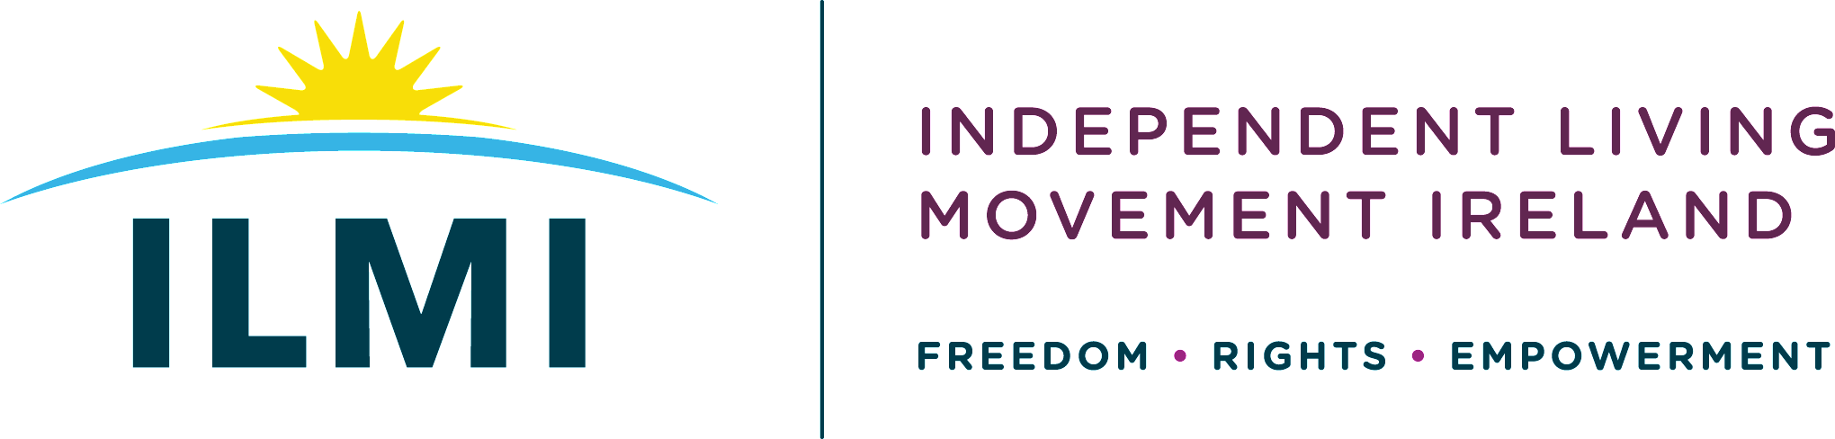
“Support and resource rights to live our lives full of dignity before embarking on discussions on dying with dignity”.
May 10th 2023
ILMI calls on Oireachtas Committee on Assisted Dying to prioritise supports for Assisted Living
Independent Living Movement Ireland (ILMI) is a cross impairment national Disabled Persons Organisation (DPO). Central to the way we work is to ensure that policy decisions that impact on the lives of disabled people have to be directly influenced by those whose lives are directly affected. Our philosophy can be summed up as: ‘Nothing about us without us!’ and ‘Rights Not Charity’. Our vision is an Ireland where disabled persons have freedom, choice and control over all aspects of their lives and can fully participate in an inclusive society as equals.
As a Disabled Person’s Organisation (DPO), we created a space for disabled people to talk about the proposed Dying with Dignity Bill at the end of 2020. Our intention was to create a safe space to capture the diversity of views that disabled people had on the Bill and to bring this as a submission to legislators at the Joint Oireachtas Committee on Justice and Equality who will receive submissions at Committee Stage of the proposed Bill.
With the recent formation of the Joint Committee on Assisted Dying, we are keen that the voice of disabled people through authentic collective DPOs needs to be fully heard in discussions about legislating for Assisted Dying.
“Nothing About Us Without Us”
The core message was that disabled people do not want to be used as pawns for either side of the debate. No politician can or should claim to speak for disabled people. Too often in discussions like this, disabled people’s lives are used as a “political football”. It is vital our voices are heard in any discussion about assisted dying legislation.
'Choice' is central to the philosophy of Independent Living. It should be about disabled people having control over all aspects in their lives and appropriate supports and resources in order to achieve our life goals. Choice should not just happen at moments of crisis or imminent death. It is the lack of choice, control and agency throughout our lifecourse that is the underlying reason why society is so inaccessible to disabled people and excludes and isolates us systematically.

The right to live our lives full of dignity
In November 2019, ILMI worked with Thomas Pringle TD to introduce a Private Members Bill to discuss the right to a Personal Assistance Service (PAS). It is telling that due to Dáil Standing Order 179 Deputy Pringle was unable to bring a PMB for debate in the Oireachtas. A motion passed on the 19th November 2019 in lieu of a PMB being introduced called “to ensure that any new legislation or Government policy on independent living conveys the right to access a personal assistance service in this country so that disabled people have choice, control and freedom to participate in society as equals”.
ILMI feels that the choice of the Oireachtas to resouce a Committee to prioritise speaking about assisting people to die as opposed to an Oireachtas Committee developing systems that would allow disabled people to live in dignity is a worrying development.

In January 2021, ILMI made a submission to the Joint Oireachtas Committee on Justice and Equality in relation to the initial draft bill (https://ilmi.ie/wp-content/uploads/2022/01/ILMI-Submission-on-the-Dying-With-Dignity-Bill.pdf). Based on this submission, we wish to raise the following key points with members of the Joint Committee on Assisted Dying:

Resourcing Disabled People to live their lives full of Dignity
Many disabled people are hugely concerned that discussions about “Assisted Dying” will inevitably lead to discussions about assisted suicide. In other jurisdictions where assisted suicide has been legislated for, disabled people frequently speak about feeling hopeless, “having nothing to live for” or feeling they would be “better off dead”.
Disabled people feel that the primary discussion needed right now is discussion about the fundamental right to live a life of dignity. That means supporting and resourcing life for everyone and ensuring people with impairments get the supports they need so they can live full lives of their choosing and not have their life options limited by society. We are at an important point as a society, where disabled people are lobbying politicians to bring about a right to a Personal Assistance Service (PAS) and it would sadden disabled people if the right to die was granted over the right to live.
Disabled people who have the supports they need to live full, independent lives with choice and control are then “freed” from lives lacking agency or hope, they can and do live lives full of value. Many disabled people in other “right to die” discussions use narratives of not wanting to be a “burden” are often talking about the impact the lack of supports to live the lives of their choosing. Disabled people feel the priority right now needs to be ensuring the supports needed for a right to live independent lives is legislated for first as a priority.
Central to any discussion around assisted dying needs to be about the quality of life supports. It should not be about people feeling that they must end their lives because lack of supports and services which means that someone who has an impairment (including an acquired impairment) not being able to experience a full life. This included that the fear that a view of “assisted suicide” could lead to disabled people making choices where through lack of supports, they begin to view themselves as a “burden” on families.
Many disabled people are opposed to Assisted Dying legislation as it could become a “slippery slope” moving from dying with dignity to assisted suicide, where the conversation changes from people who are terminally ill to people choosing to end their lives, which in other jurisdictions has often focused on people with impairments, who without the supports to live a free full life feel that their lives are not worth living. There are fears which are real and justified on very recent history. We live in a society that is obsessed by “productivity”.
In other jurisdictions, assisted dying often gives medical authority to judge “quality of life”. Discussions about assisted living discussions in other jurisdictions are often enshrined in a medical discussion of disability as opposed to a more rights-based social model of disability. It is only eighty years ago that across Europe people who were viewed as “unfit” or a “burden” in society were murdered in their thousands.
Many disabled have huge concerns about assisted dying and who would decide and how, including the capacity of people making choices about their lives. If the discussion moves from people who are terminally ill towards discussions about “quality of life”, then who decides what quality of life? In other jurisdictions, conversations about assisted suicide have led to societal discussions about “quality of life” which have impacted on disabled people.
The Social Model of Disability Needs to inform any discussions about how disabled people are included in Irish Society
The social model looks at how society is structured and how it disables people. It isn’t based on a person’s impairment, it is about what barriers that exist in terms of attitudes, policy development, access or lack of supports that prevent people from participating in society as equals, with choice and control over their own lives. In this model it is society that disables people from achieving their hopes and dreams, not a person’s impairment.
The social model informs all aspects of the work of ILMI. As a campaigning, national representative organisation that promotes the philosophy of independent living we are working to build an inclusive society. Central to the way we work is to ensure that policy decisions that impact on the lives of disabled people must be directly influenced by those whose lives are directly affected.
ILMI’s work is to develop policies and campaigns based on disabled people’s lived experiences in order to remove barriers that restrict life choices for disabled people. When barriers are removed, disabled people can be independent and equal in society, with choice and control over their own lives. Barriers are not just physical. Attitudes found in society, based on prejudice or stereotypes (also called disablism), also disable people from having equal opportunities to be part of society. Disabled people developed the social model of disability because the traditional medical model did not explain their personal experience of disability or help to develop more inclusive ways of living.
The social model of disability informs key International Conventions such as the UN Convention of the Rights of People with Disabilities (UNCRPD) and is in contrast to the “medical / charity model” of disability.
The medical / charity model individualises disability and promotes the idea that people are disabled by their impairments or differences. The medical model always focuses on people’s impairments from a medical perspective. In some ways it still looks at what is ‘wrong’ with the person and not what the person needs. It creates low expectations and leads to people losing independence, choice and control in their own lives. The medical / charity model never recognises the rights of disabled people and assumes that disabled people need to be “looked after” or “cared for”. The medical / charity model has professionals make decisions for disabled people. People informed by the medical / charity model, being focused on disabled people’s impairments, use the term “people with disabilities”.
Disabled People and the right to life
ILMI have concerns that assisted dying legislation in other jurisdictions reinforces the medical view of disability, including naming of specific impairments within legislation is of huge concern to disabled people. Many disabled feel that an attempt to provide a definitive medical definition of “terminal illness” is problematic as it can never be precise. Identifying impairments in the legislation could lead to people with certain impairments viewing their lives as worth living or not. What Ireland needs is a conversation about the needs of disabled people: proper practical, emotional and medical support needed to live dignified lives.
In other jurisdictions during Covid-19, the lives of disabled people were not valued or treated equally in terms of protection and care. Disabled people were told that their lives were not worth saving. Whilst disabled people in Ireland did not face such discrimination, we need to be mindful of any discourse in relation to assisted dying that can trigger commentary with eugenic overtones about who is “worthy” of supports to live .
Resourcing end of life supports for everyone
Any discussion about dying with dignity needs to look at the resourcing for a high-quality palliative care system, which is respectful and supportive of people at the end of their lives, which recognises the role of families. The role that hospices play is vital in Irish society, yet they have to fundraise continuously. End of life care needs to be recognised as a vital part of our health care system and resourced accordingly. Many countries have advanced health care directives, which need to be addressed in any full discussion about death and dignity.
Disabled People and the Right to Chose
Some disabled people do feel strongly felt that assisted dying is a natural expression of choice and equality and being in control of the fundamental aspects of their lives. Many people have seen people in the end of terminal diseases wracked with pain, and felt that this was something that they do not wish to see again. It also could be seen as the “final” human right for people who wish to leave the world at their choosing, free from pain.
Assisted Dying Legislation and ILMI as a DPO
LMI continues to create spaces for disabled people to discuss concerns of the potential consequences of Assisted Dying legislation. We have linked in with international DPOs, including Not Dead Yet UK, and featured a webinar with Phil Friend from Not Dead Yet, who spoke about how DPOs in the UK have challenged “Assisted Suicide” legislation.
We have included a link (below) to our Youtube Channel for members of the Oireachtas Committee on Assisted Dying to learn more about this discussion.

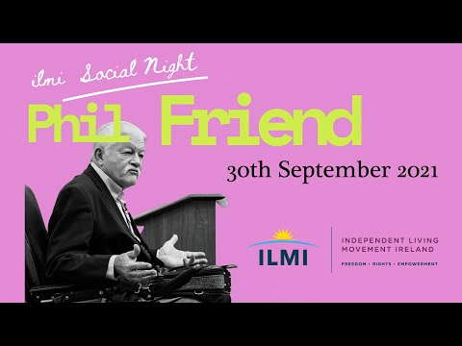
For more information, visit www.ilmi.e or email info@ilmi.ie

https://www.theguardian.com/world/2021/feb/13/new-do-not-resuscitate-orders-imposed-on-covid-19-patients-with-learning-difficulties

