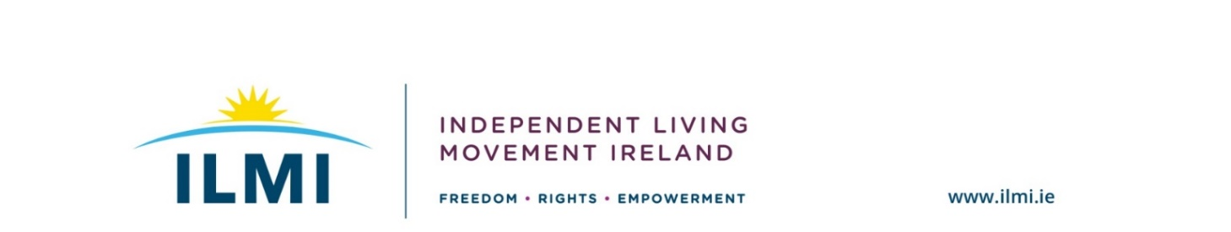

Our members have identified the following as the Core aspects of our Election 2020 Campaign:
.
- Personal Assistance Service
We want all political parties to commit to introduce legislation to guarantee us the right to a Personal Assistance Service (PAS) as per Article 19 of the UN Convention on the Rights of Persons with Disabilities (UNCRPD).

We want to be part of welcoming inclusive communities where we are connected to other people and where we have choice and control of how we live our lives. The Personal Assistance Service is a tool that allows us to live independently. A Personal Assistant (PA) is hired to assist us with a range of day-to-day tasks both inside and outside of the home, in work, college or social settings. This provides us with the freedom and flexibility we need to live our lives as we choose. It is about giving us the choice to live the lives we wish We delegate these tasks to our PAs and in doing so take back control of our lives.

In November 2019, a unanimous motion was passed in the Dáil to legislate for PAS and we want to continue this momentum. Currently, only 5% of the HSE's disability budget goes on personal assistance. Meanwhile, 85% of the budget is spent on residential and day services, which could have given freedom to thousands of Disabled people through the provision of Personal Assistance.

- Participation
Disabled people want to have their views heard and valued to advance equality, social justice and sustainability through active engagement in decision-making, rebalancing of power in this process, and investing resources to support this engagement.

For far too long disabled people have been excluded from participation in decision making structures at all levels. We want all political parties to commit to direct engagement with genuine Disabled Persons’ Organisations and ensure that they are resourced so that we can engage effectively in policy development.

“Nothing about us without us”: the role of Disabled Persons’ Organisations (DPOs) is crucial as unlike disability services providers, they are led by Disabled People and this forum is where we need to have our contributions heard and recognised in policy development.

Funding is the true recognition of commitment and support of the independence of DPOs in our campaigning work. A new funding stream which is separate to the Health Service Executive (HSE) should be advanced by government through the Department of Justice and Equality.

- Housing
Everyone deserves to call somewhere home. We want all political parties to commit a minimum of 10% of all social housing in their election manifestos and the development of any future programme for Government.

There always has been a housing crisis for disabled people due to the lack of decent accessible housing and support packages in place. We are more than twice as likely to report discrimination relating to housing and over 1.6 times more likely to live in poor conditions, such as extremely damp housing, lacking central heating or living in an area with neighbourhood problems. We are also particularly over-represented in the homeless population: more than one in four homeless people are disabled.

There are also many disabled people among the hidden homeless living in other people’s homes who are not on any housing list and for whom there is no expectation that they should live independent lives. There are also thousands of disabled people in residential and congregated settings who are denied a right to their own home due to ineffective housing policy.

Reliance on the Private Sector will not work and does not work for us, due to our particular accommodation needs and therefore many of us require investment in Public Housing.

Independent Living Movement Ireland Election Manifesto 2020

Independent Living Movement Ireland (ILMI) is a campaigning, national representative organisation that promotes the philosophy of independent living and seeks to build a truly inclusive society for disabled people. Our philosophy is: ‘Nothing about us without us!’ and “rights, not charity”.

Central to the way we work is to ensure that policy decisions that impact on the lives of disabled people must be directly influenced by those whose lives are affected by these decisions.

We are a Disabled Persons’ Organisation (DPO) and we have highlighted our key asks to be included in Party Manifestos in the lead-in to Election 2020. We will work with disabled people across the country to ensure disabled people are mobilised to have their voices heard.

