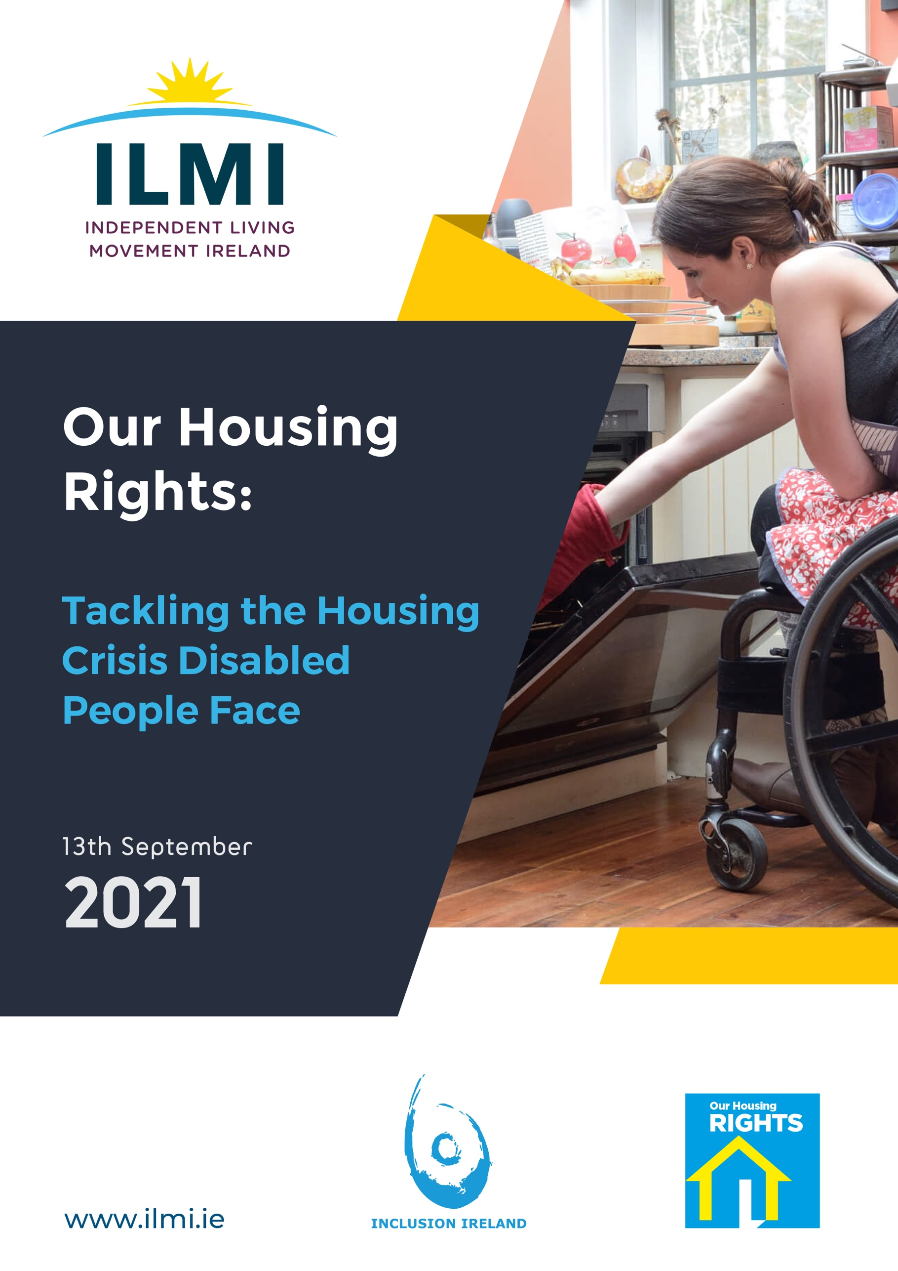

About Inclusion Ireland
Established in 1961, Inclusion Ireland is a national, rights-based advocacy organisation that works to promote the rights of people with an intellectual disability.
The vision of Inclusion Ireland is that of people with an intellectual disability living and participating in the community with equal rights.
Inclusion Ireland’s work is underpinned by the values of dignity, inclusion, social justice, democracy and autonomy and we use the United Nations Convention on the Rights of Persons with Disabilities (UNCRPD) to guide our work.

About Independent Living Movement Ireland (ILMI)

Independent Living Movement Ireland (ILMI) is a campaigning, national Disabled Person’s Organisation (DPO) that promotes the philosophy of independent living and seeks to build an inclusive society. Central to the way we work is to ensure that policy decisions that impact on the lives of disabled people have to be directly influenced by those whose lives are directly affected.

Our philosophy can be summed up as: ‘Nothing about us without us!’ and ‘Rights Not Charity’. Our vision is an Ireland where disabled persons have freedom, choice and control over all aspects of their lives and can fully participate in an inclusive society as equals.

Easy to Read Information
Inclusion Ireland and Independent Living Movement Ireland (ILMI) ran focus groups about housing in July 2021.
We know that there is a housing crisis for disabled people in Ireland.
A crisis is an emergency. There is not enough housing that works well for disabled people and this needs to change.
We wanted to hear what changes disabled people want to happen to make housing better for everyone.
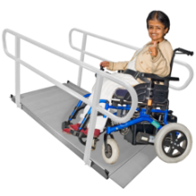
In the focus groups we asked disabled people and family members these questions:

- What has been your experience in trying to find accessible housing and what changes would you like to see?

- What has been your experience in relation to getting affordable housing and what changes would you like to see?

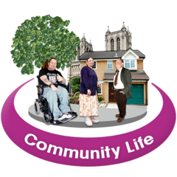
- What are the housing and support services you need to live independently in the community and what has been your experience in accessing those?

We wrote a report after the focus groups, and this is the summary of that report.
You can use this summary to know the important messages if you take part in consultations about the Housing Strategy for Disabled People.

The Housing Strategy for Disabled People is a plan the Government is making about work they will do to make housing better for disabled people. This report will help us explain what needs to be in the new strategy.
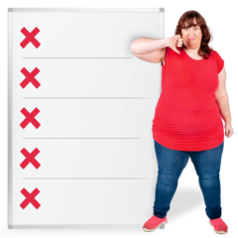
What are the problems in housing for disabled people now?

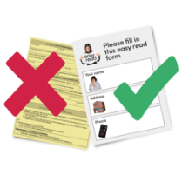
Applying for Housing
Many disabled people find it hard to apply for housing.
It is hard to fill out the forms and hard to know what you need to do.
Local authorities, city and county councils and the HSE don’t always work together so this makes it harder for disabled people to apply for housing. The way to apply can be different in different areas of the country
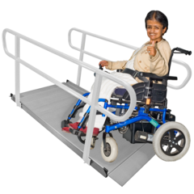

Accessible Housing

Accessible housing is very hard to get.
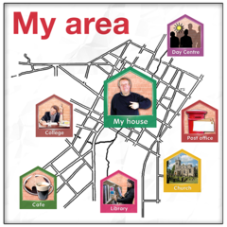
An accessible house is so much more than access to the building, it includes where your house is, being near accessible transport links, assistive technology and much more.

Where you live is important, you need to be near transport shops and where the activities happen. Disabled people don’t often have choice in this.

Affordable Housing

There are very few houses that disabled people can afford. Houses are too expensive to buy or rent and the prices keep going up. It is hard to afford housing on social welfare payments or if you experience poverty.
Grants and building rules are not working well and need to be reviewed.

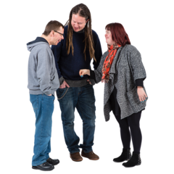
Independent Living Supports
Independent living supports such as a personal assistance service or home support are impossible to get now.

This makes it really hard for disabled people to live independently and get the support they need.

Nursing Homes and Congregated Settings
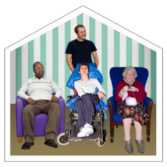
There are over 4000 disabled people living in institutions such as people under 65 years of age living in nursing homes and people living in a congregated setting like a residential service.

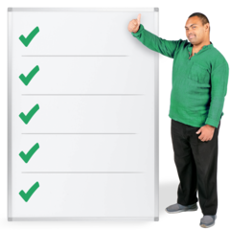
Many disabled people are living in the family home with an aging carer. At least 400 carers are over the age of 80.

What do disabled people need to happen to tackle or fix the housing crisis?

Applying for Housing
We need one accessible, way to apply for housing and independent living supports that is the same in every area of the country.

The way to apply must be accessible and easy to understand for disabled people.

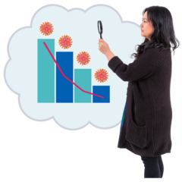
We need to have information about waiting lists for housing and independent living supports. It needs to include where people are from and how long they have been waiting.

Accessible Housing

7.5% of all new social housing, and affordable housing must be for disabled people and designed using universal design. This will mean housing will be accessible for disabled people.

Independent Living Supports

The HSE, the Department of Housing, and the Department of Children Equality Disability Integration and Youth must work together to put systems in place that make sure housing and supports are offered to disabled people at the same time. Housing without supports is useless.

The Government must make laws to put personal assistance in place for people who need them.

We need advocacy supports when applying for a house, applying for a support package, or applying for a personal budget.

Affordable Housing

The Government needs to spend enough money on housing and independent living support packages. These need to be available to all disabled people no matter what needs they have.

The rules for the Housing Adaptation Grant must be looked at and changed to make it better so people can change their house to make it more accessible if they need to.
Part M of the building rules need to be looked at and checked so houses are accessible when they are built.

Nursing homes and congregated settings
The Government and the HSE must plan to move people under 65 living out of nursing homes into independent living arrangements in the community.
The Government must make a plan move residents from congregated settings and residential services into independent living over five years.

Key messages
- At present there is a housing crisis for disabled people in Ireland.
- The system of applying for a house and independent living supports is complex and is characterised by a lack of transparency and little cooperation between local authorities and the HSE.
- Independent living supports such as a personal assistance service or home support are very hard to get at present.
- Accessible homes are hard to get at present. This is in part due to inadequate regulations (Part M) and a lack of enforcement.
- An accessible home is so much more than physical access. It includes the location, accessible transport links, assistive technology and much more.
- Local Authority housing adaptation grants are inadequate and have a “harsh means test”.
- There are virtually no affordable homes that disabled people can afford given excessive poverty rates and the cost of living with a disability.
- There are just over 4000 disabled people living in inappropriate institutional settings such as people under 65 years of age living in nursing homes and people living in a congregated setting.
- Many disabled people are living in the family home with an aging carer of whom, at least 400 are over the age of 80.

The United Nations Convention on the Rights of Persons with Disabilities (UNCRPD)

Article 19 – Living independently and being included in the community
Ireland ratified the UNCRPD in 2018. States Parties who have ratified the present Convention recognize the equal right of all persons with disabilities to live in the community, with choices equal to others, and shall take effective and appropriate measures to facilitate full enjoyment by persons with disabilities of this right and their full inclusion and participation in the community, including by ensuring that:

a) Persons with disabilities have the opportunity to choose their place of residence and where and with whom they live on an equal basis with others and are not obliged to live in a particular living arrangement;
b) Persons with disabilities have access to a range of in-home, residential and other community support services, including personal assistance necessary to support living and inclusion in the community, and to prevent isolation or segregation from the community;
c) Community services and facilities for the general population are available on an equal basis to persons with disabilities and are responsive to their needs.

The current situation
This report reflects the housing and independent living support situation for disabled people in Ireland at present. The recommendations in this report are set out to mirror what the new housing strategy for disabled people should include. Members of ILMI and Inclusion Ireland have long raised the housing crisis that exists for disabled people in Ireland in today. This is not a simple problem as it involves numerous different situations and will require multiple housing solutions for disabled people to what has become an almost invisible housing crisis within a broader housing crisis. The situation for disabled people is exacerbated by high purchase and rentals costs, high levels of poverty, discrimination and poor levels of employment.
- At present, 2841 people are living in congregated settings.
- At present more than 1300 people under the age of 65 are living in nursing homes.
- At present there is a shortfall of between 800 and 2300 residential places in disability services meaning the HSE will need to provide 90 additional places each year up to 2032 to meet demand.
- The unmet need for a personal assistance service (PAS) has not been accurately measured. Significant investment is required of €4m in 2022, rising to €15m in 2032. It is estimated that an investment of €30m per year is needed to address the need of people not in receipt of any PAS service at present.
- About 2,500 people get a PA service averaging around 12 hours a week, often people who require a personal assistance service to live independently are not receiving a service which meets their needs to have choice and control over their lives. Information in the Disability Capacity Review to 2032 confirms that from 2008 to 2018 there was no increase in the number of hours under the personal assistance service (PAS).
- More than 1250 disabled people are living at home with a primary carer over the age of 70 with 400 of these carers over the age of 80.
- Disabled people make up 13.5% of the population but make up 27% of the homeless population.
- The at risk of poverty rate among people out of work due to disability is 37.5% as opposed to 12.8% in the general population. This is mainly due to low employment rates for disabled people.
- In 2020, the HSE planned to fund 8358 residential places. This is due to increase by 102 places in 2021.
- In 2021, the HSE aims to acquire 30 homes to move 144 people out of congregated settings.
- In 2020, the HSE had a target to deliver 1,670,000 personal assistance hours.

Process
On July 7th,2021 Inclusion Ireland and ILMI held six focus groups on the issue of housing as this is the greatest issue for the members of both organisations at present. Four of the focus groups were attended by disabled people and two were for family members of disabled people. This report is a reflection of their experiences at an individual level and also at a systemic level of trying to gain access to housing and the supports to live in a home of their own.

At the focus groups participants were asked to consider three questions.
Q 1. What has been your experience in trying to find accessible housing and what changes would you like to see?
Q 2. What has been your experience in relation to getting affordable housing and what changes would you like to see?
Q 3. What are the housing and support services you need to live independently in the community and what has been your experience in accessing those?

Accessible housing
Issues raised in focus groups
Universal design
Accessible housing is a complex issue. It is much more than having a house that is wheelchair friendly. People commented that universal design principles should be adopted in a ring-fenced number of social and private houses to ensure accessibility for as many people as possible.
“The demographic of disability is so diverse and needs to be factored into builds. People have very individual and diverse needs.”
“I lived in a place that was accessible, but when I moved, I couldn’t get a suitable place, and my changing needs, and difficulties in getting landlords to adapt and accommodate for needs.”

Location
People noted that many disabled people do not drive, and public transport is not always accessible, so a home needs to be centrally located for services or located close to public transport options. It is essential for community living that disabled people have easy access to shops and local services. For rural dwellers, the accessibility of the community and services is an even greater difficulty.

Application process
The system itself of applying for a house and the associated supports required to live independently is not accessible to many people. The system is confusing.
A disabled person must apply for housing with their local authority and then there is added confusion in attempting to apply for social care supports to live independently.
There is no clear pathway to apply for supports, and very little engagement between the local authority and the HSE on the provision of the house and the required supports. Many people spoke of the ‘Catch 22 situation’ where you cannot get the house without a support package and that the support package is almost impossible to obtain.
“It is impossible to plan. There is no provision and no clear pathway to move along.”
“The Local Authority tell us that we cannot access housing as we need significant support to live independently. The HSE tell us that we cannot get an accessible house as we need to be on the Local Authority list. We have been left in no-man’s land”.
Waiting lists
The extensive waiting lists for social housing through Local Authorities is pushing people into availing of the HAP scheme. However, most private rental accommodations are not accessible to most disabled people. There really is no onus on landlords to make housing accessible as the Part M building regulations are weak and outdated.
“The ridiculously long waiting list and complicated form filling, people are waiting for years!!!! It’s not good enough.”

Inadequacy of housing grants
The Department of Housing has a grant for making home adaptations to enable disabled people to continue living at home. Participants noted that the means test applied to this grant is harsh and the amount of the grant often does not cover the cost of home adaptation. Some participants built their own home. The home adaptation grant is not available for new build homes even though accessibility costs are often significant.
Smart technology and assistive technology
Smart technology and assistive technology is not factored into housing as an accessibility requirement. For example, accessible cooking equipment is not a feature in new homes, but such aids are essential for people with a visual impairment. For other people, voice activated home appliances and smart devices are essential independent living supports.
“Accessibility is much more than just a wet room. Other appliances and accommodations such as smart technology need to be factored in.”
“If the Government are serious about creating accessible houses they have to be fit for purpose and tailored to the needs and requirements (of the person).”

Possible solutions.
- 7.5% of all new housing stock must be constructed within the principles of universal design.
- Part M of the Building Regulations needs to be reviewed so that the accessibility standard for all new builds will be higher. In reviewing Part M, there needs to be a disability access officer within local authorities. This role should be similar to a fire prevention officer to enforce regulations relating to part M, including inspections of new and existing buildings to ensure standards of access are being met.”
- Social and affordable housing must be constructed in centrally located areas or areas with good, accessible public transport for ease of access to the local community. A simple, fully accessible central application process must be established where a person can apply for a house and independent living supports.

Affordable housing
Issues raised in focus groups
Poverty
The message on affordable housing from disabled people is that it does not exist at present as an option. Employment rates for disabled people are well below the rate for the general population and consequently poverty rates are much higher. This leaves disabled people at a disadvantage in purchasing or renting a home of their own. Participants stated they often had to rely on family for assistance with deposits and rent. Private rentals are not affordable to disabled people and, as noted in many cases are not accessible.
Cost of disability
Participants noted the hidden costs of housing for disabled persons. Many of these hidden costs are not faced by the general public and are known as ‘the cost of disability’. Such costs include additional heating requirements, small home adaptations, assistive technology for the home, maintenance, etc. Government has been researching the cost of disability with scope to introduce a payment to mitigate against these costs.
Inadequate/inaccessible HAP
The HAP scheme can take a period to get set up meaning the person must have a significant amount of money available to access HAP. Typically, a person may pay a deposit and a number of months rental before HAP is processed leaving it unaffordable to many disabled people.
“Affordable housing is not affordable any more to disabled people. We do not earn as much as others. Rent of €1000 per month is unaffordable.”
“Rent needs to go down for us to afford it. I will have to leave my current home as I can barely afford the rent. There is very little money left for shopping or other bills.”
Affordable housing applications
The affordable housing system is also very confusing to navigate. Focus group participants noted that there were earning limits on people trying to access social housing and then earning bands for people trying to buy an affordable home. These rates can be different in different parts of the country leading to additional confusion.
Unavailability of social housing
Social housing is not being built at a rate that makes it a real option for disabled people unless they are prepared to wait for many years on a housing waiting list (the inaccessibility of the scheme is noted in the previous section). Focus group participants noted that many of them were waiting years to access a social home.
“The residential service provider wants those seeking accommodation to apply for HAP as housing waiting list times are very long, we know of people on list for 15 years, so we can’t see how that might work.”
Inaccessible home adaptation scheme
As noted in the section on accessibility there is a home adaptation scheme to enable people to remain in their home by making it accessible for their needs. However, the scheme is subject to a means test that excludes many people. This restrictive criterion leads to people living in unsuitable homes due to not being able to afford to carry out accessibility work to their home and not qualifying for the home adaptation grant.

Possible solutions
- Remove the means test on the home adaptation grant to ensure disabled people can make the required adaptations to remain comfortable in their own home.
- Publish the Government research on ‘Cost of Disability’ and introduce a payment without delay.
- Reform the HAP scheme to ensure disabled people and their families are not running up significant debt to access a home.
- Increase the stock of social housing for disabled persons. Ring-fence 7.5% of all new social and affordable homes.
- Ensure affordable homes are affordable.
- A simple, accessible information service is required to let people know of the various schemes, supports and how to apply for these.
- Engage with disabled people through their representative organisations to gain their expert knowledge of the housing issues affecting their lives.

Independent living supports
Issues raised in focus groups
Lack of choice and negative attitudes
People pointed out that ‘the system’ often does not see disabled people as rights holders and that they are often spoken down to. People spoke about wanting choice about who they live with, where they live, the supports they receive and about wanting to move out from their parents’ home at a similar time to their non-disabled peers. A number of participants wanted help in building their own capacity in ‘engaging with the system’ to be able to assert their needs.
“I want to live near my friends, for a social life and interaction. Flexibility to do what I want and to have people come to my house.”
“Community living – I want to live with people I get on with, and have real proper choices, rurality and isolation is difficult.”
“Need supports to have a direct affirmative voice to assert our rights to housing and supports to live independent living.”
Absence of formal application to live independently
The supports for independent living or to live in a house with other people is the main issue in the housing crisis for disabled people at present. Focus group participants spoke about not knowing how to apply for supports to live independently or who to apply to and of the different avenues they pursued. There is no formal application process for support like the application for the physical house and there is no consistency from one HSE area to another. People do not get feedback where they are on a list.
“Housing is not the problem. It is all subject to HSE funding, that is the barrier.”
“No continuity of service of supports or who we engage with in terms of accessing supports or housing.”
“People with intellectual disability are excluded from social housing because they cannot get funding for supported living.”

Lack of access to a personalised budget for people in residential services
People spoke positively of the introduction of a model of personal budgets and that this may be a way forward for people to secure supports to live independently. However, the experience of people so far with personal budgets highlights issues. One of the main barriers to obtaining a personal budget is the reluctance of large service providers to ‘unbundle’ funding to individuals. Participants noted that the unbundling of funds was an issue for people moving from congregated settings and as a result very few have moved into a home of their own, but into community group homes.
“We need personalised budgets. Adequate funding is needed to ensure we can live independently. The reality is that most large-scale service providers don’t want to part with their funding.”
Lack of understanding on support required
Focus group participants pointed to a limited understanding of the types of support disabled people require to live independent lives. For example, one person with a visual impairment noted that he required no personal supports but needed access to assistive technology such as voice activated appliances. Other supports that people said they required included, training on managing a household budget, transport to their day service or job, help with shopping, specific supports such as for autism, help with home maintenance, etc.
Lack of support to live independently
At present there are very few options for people to acquire the necessary supports to live independently. This is having a significant impact on disabled people and their families. Disabled people are aging in the family home with their aging parents. There is a denial of a right to live independently coupled with an onus on families to provide care when they are aging.
Possible solutions
- Greater access to the personal budget’s demonstration project. This should include people previously with no budget. Services must be told to unbundle funds where requested.
- Introduce legislation for a statutory PAS and ensure it is adequately funded as per the projections in the Disability Capacity Review to 2032.
- Greater access to advocacy support. This is essential where supports for independent living or a personal budget are being negotiated.
- Disabled people should have access to capacity building training to increase their capacity to speak up on these issues themselves.
- A central accessible, information and application point for housing and the support required to live independently.
- The HSE and the Department of Housing and Children, Equality, Disability, Integration and Youth to work together on ensuring the home and support is provided together.
- A central waiting list must be collated and published that details the amount of disabled people awaiting housing and supports.
- Appropriate resources need to be made available to ensure there is access to independent living supports regardless of the level or type of a person’s impairment.

Additional considerations
The issue
Online focus groups are limited for disabled people. Some people are very hard to reach due to their place of residence or their capacity to take part in an online focus group.
A Time to Move on From Congregated Settings – a Strategy for Community Inclusion was published in 2012 with an aim to move all people into community settings by 2018. At the end of 2020, there was 2841 people living in a congregated setting.
In 2021, the Office of the Ombudsman published an investigative report on disabled people who are currently living in nursing homes. The Wasted Lives report stated that there is more than 1300 disabled people under the age of 65 inappropriately living in nursing homes.
Possible solutions
- Government must resource the HSE to move the remaining people from congregated settings to homes in the community over a 5-year period.
- Government must devise a plan to move the 1300 people inappropriately living in nursing homes to supported living arrangements in the community.
- Both of these schemes should be complemented with access to ‘home care’ services (e.g. PA support or home support) underpinned by legislation.
- Progress and fully implement personalised budgets giving the disabled person and their family choice and control.

Recommendations
The following recommendations should be included in the new Housing Strategy for Disabled People.
Systemic
- A central, accessible application process for housing and independent living supports must be established.
- The application process for housing and supports must be the same across all areas of the country.
- Robust data must be published at regular intervals on waiting lists for housing and independent living supports. This data should be disaggregated and include county data, housing need data, support package need data and waiting time data.
- 7.5% of all new social housing and housing provided by approved housing bodies must be ring-fenced for disabled people.
- At a national level, the HSE, the Department of Housing, Local Government and Heritage and the Department of Children, Equality, Disability, Integration and Youth must work together to put systems in place that ensure houses and supports are offered to disabled people simultaneously.
- At a local level, the HSE and local authorities need to work together to ensure housing and supports are offered simultaneously.
- The Government must introduce legislation to put PAS on a statutory footing.
- The Government needs to adequately resource both housing and independent living supports.
- All local authority, housing disability steering groups must have representation of disabled people as per the UNCRPD, Article 4 and 29.
- Advocacy supports must be made available to disabled people. Points where advocacy support is required includes applying for a house, applying for a support package, or applying for a personal budget.
- A clear and robust assessment tool for independent living support must be applied with the disabled person fully involved and engaged.
- A clear and robust assessment tool for personal budgets must be applied with the disabled person fully involved and engaged.

Accessibility
- A central, accessible information point on all housing and independent living support options must be established and resourced.
- Information on housing and independent living support options must be promoted widely to disabled people and their family members. This includes people living in congregated settings.
- 7.5% of all new social housing and housing provided by approved housing bodies must be built to universal design principles.
- Part M of the building regulations needs to be reviewed to ensure accessibility standards in all houses is raised.
- In reviewing Part M, there needs to be a disability access officer within local authorities. This role should be similar to a fire prevention officer to enforce regulations relating to part M, including inspections of new and existing buildings to ensure standards of access are being met.
- Homes for disabled people must be built in locations that are accessible to local communities and services or close to accessible transport links. Specific consideration is required for rural developments.
- Specific transport solutions must be available for people who access a day service support.
- Housing provision should strive to include assistive and smart technology to support people to live independently.

Affordability
- The means test for the Housing Adaptation Grant must be reviewed or abolished.
- The Housing Adaptation Grant must be made available to people building their own home.
- 7.5 % of affordable homes should be made affordable for disabled people.
- Review and reform the Housing Assistance Payment to ensure disabled people and their families to not have to enter into debt to access a home.
- Publish the ‘Cost of Disability’ research undertaken by Government and introduce a cost of disability payment.

Independent living supports
- Government must resource the HSE to provide additional support packages to enable disabled people to live independently such as personal assistance, home help or other independent living supports.
- A disabled person should be able to access supports to live independently regardless of their level of impairment or support need once they reach the top of the housing list.
- Capacity building must be made available to individuals who require it to support their independent living. This should include, managing a home budget, home maintenance, community inclusion, using transport, etc.
- Greater use of personalised budgets must be made available to support independent living.
- People not currently receiving a HSE service should be able to apply for a personalised budget to live independently.
- 15% of the current spend on residential services should be directed towards supporting people into independent living arrangements.

Nursing homes:
- Government and the HSE must plan to move people under 65 living in nursing homes into independent living arrangements.
- Moving people from nursing homes to community settings needs close co-operation of Government Departments and the HSE.
- Any policy will require a fully costed implementation plan with targets and timelines.
- Government must introduce a statutory ‘home care’ scheme that is accessible to disabled people living in nursing homes and congregated settings.
- People moving must have access to independent advocacy.
- Any moves must be meticulously planned to ensure that people are fully integrated into their community and community care services.

Congregated settings
- Set out a plan that is fully costed to move the remaining residents from congregated settings into community settings over a five-year period.
- Review progress to date on moving people from congregated settings. Use methods and process that have worked well to date.
- Any moves must be meticulously planned to ensure that people are fully integrated into their community and community care services.
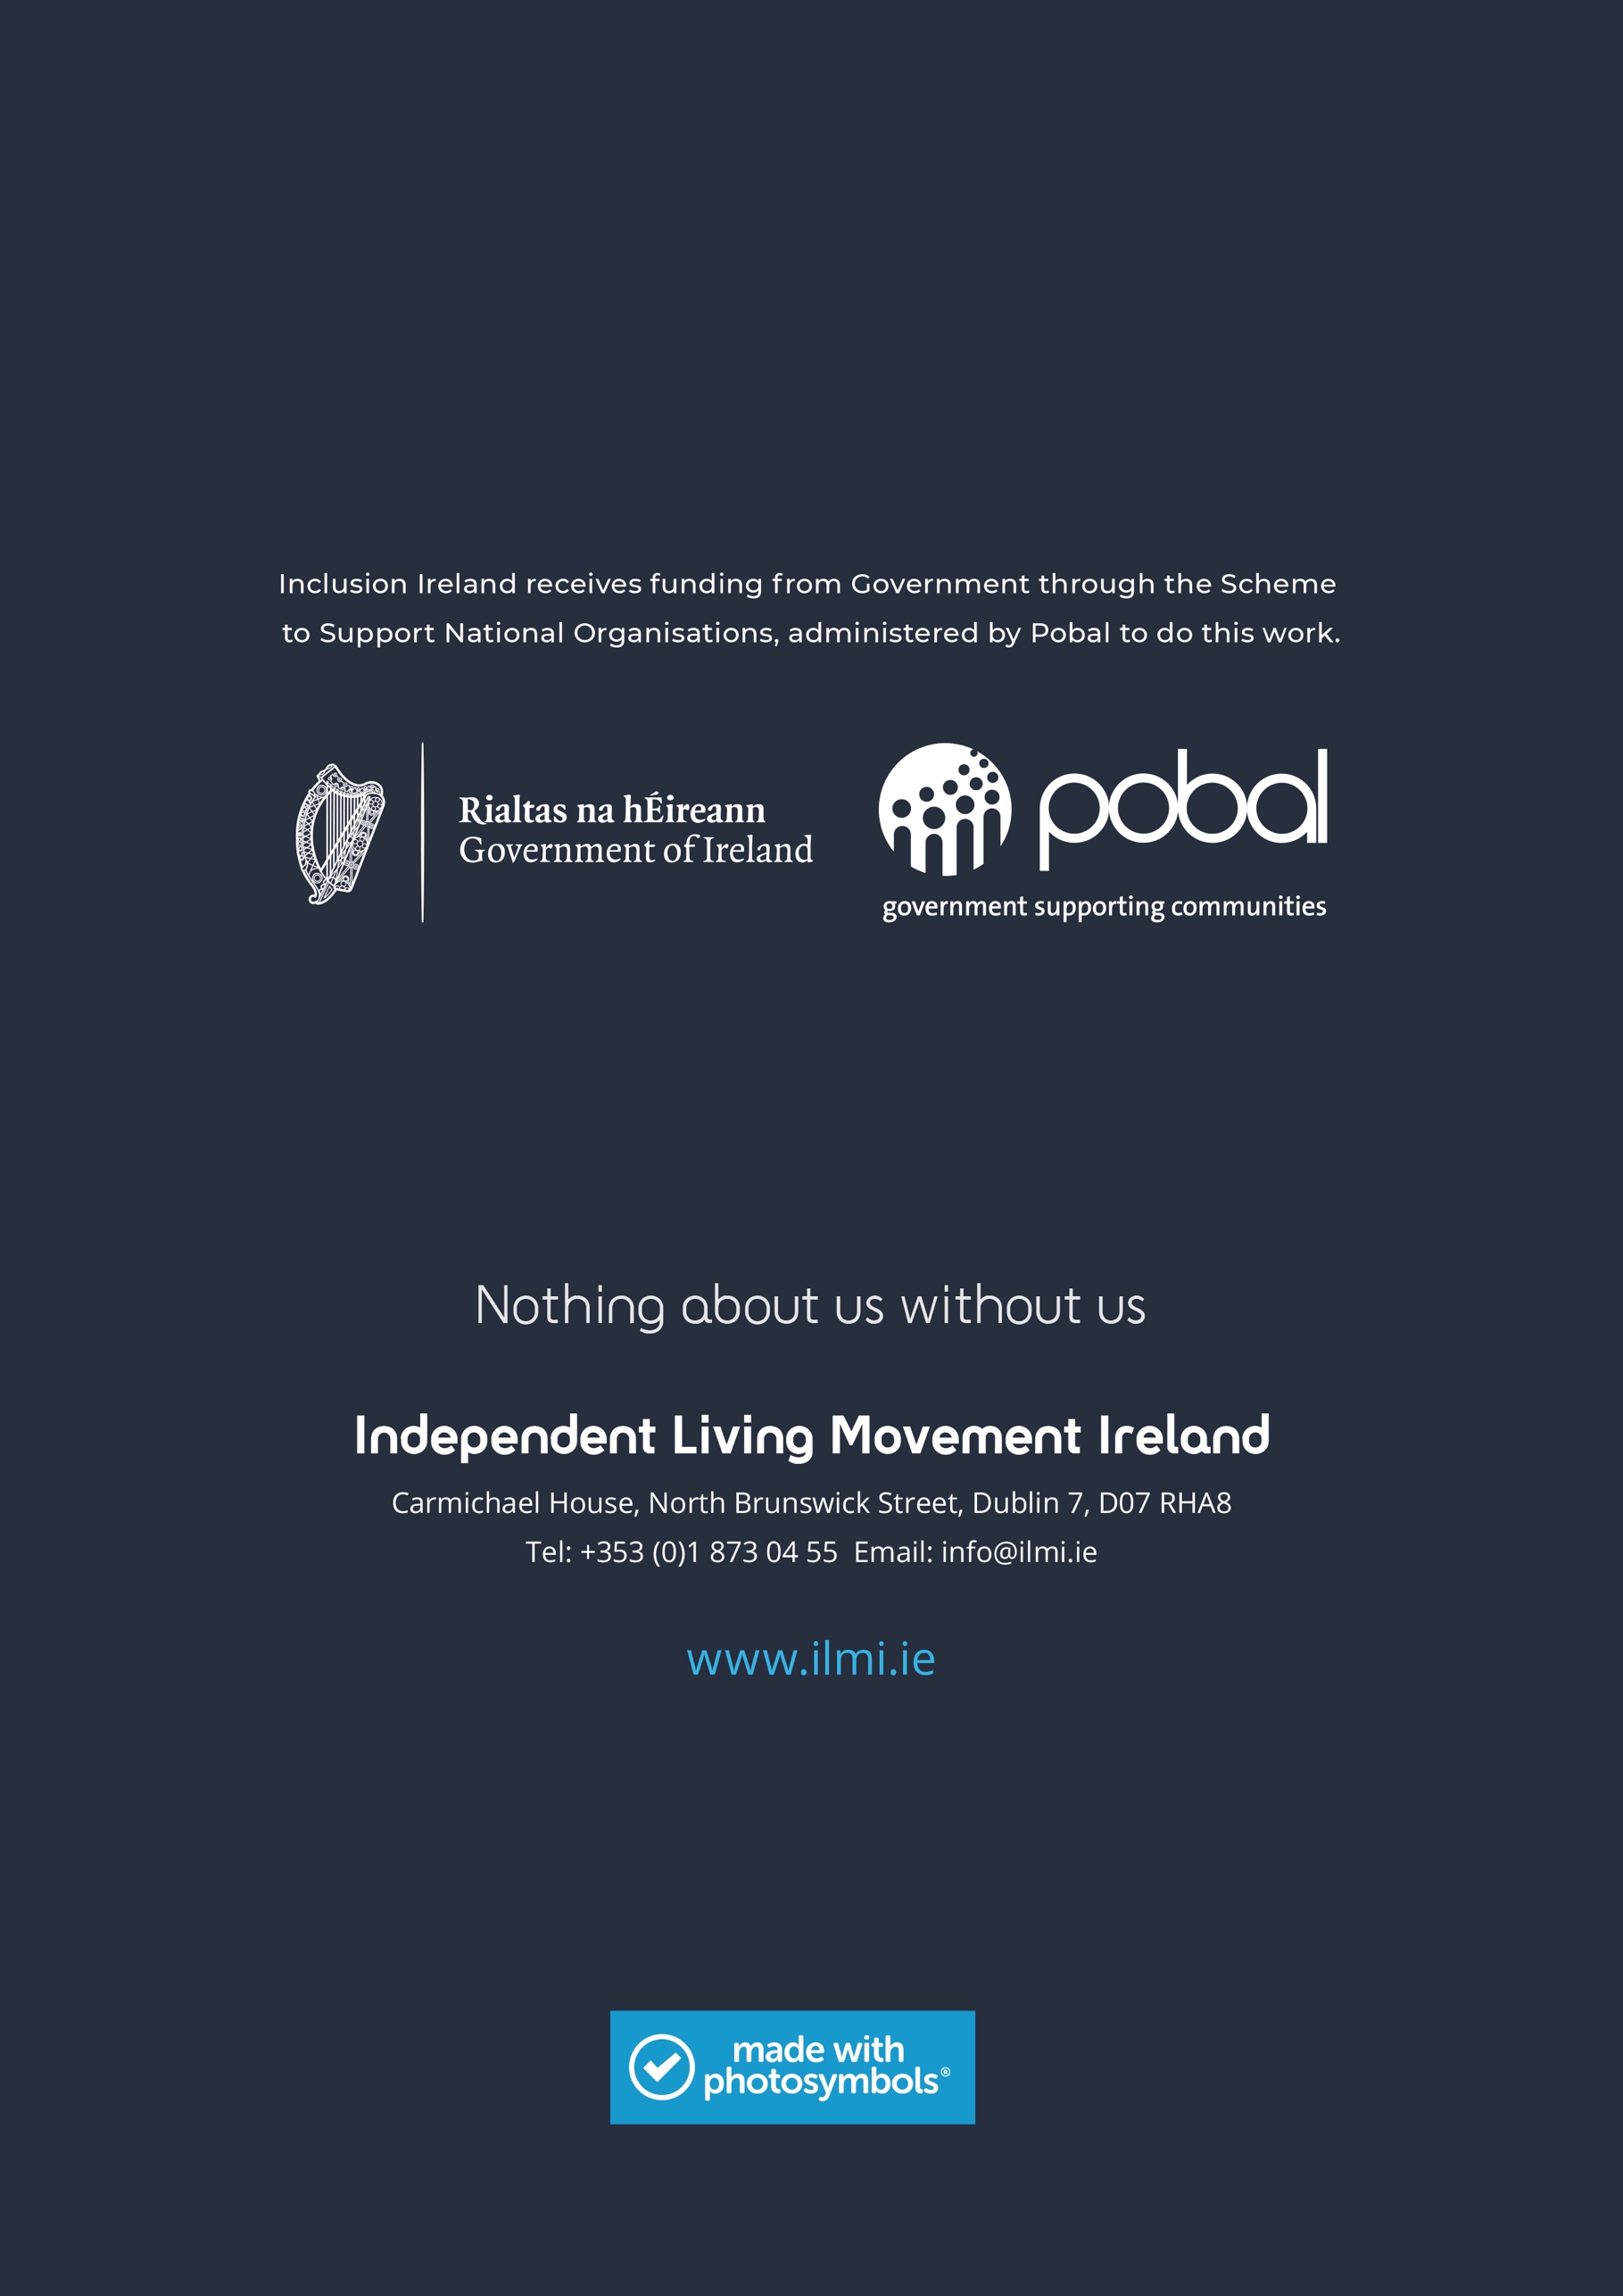

HIQA Annual Report 2020.
Office of the Ombudsman, Wasted Lives-Time for a better future for younger people in nursing homes, 2021.
Department of Health, Disability Capacity Review to 2032, 2021.
Ibid
National Federation of Voluntary Service Providers, Members survey, 2020.
Central Statistics Office, Census 2016.
Central Statistics Office, SILC, 2019.
HSE, Service Plan for 2021.
Ibid
HSE, Health Services Performance Profile July - September 2020
http://universaldesign.ie/Built-Environment/Building-for-Everyone/
Central Statistics Office, SILC, 2019.
HIQA Annual Report 2020.
Office of the Ombudsman, Wasted Lives-Time for a better future for younger people in nursing homes, 2021.

